Tetra Tech International Development Careers Site

MyCareers Navigation

Once you have established your MyCareers account there are several navigation options available to you.

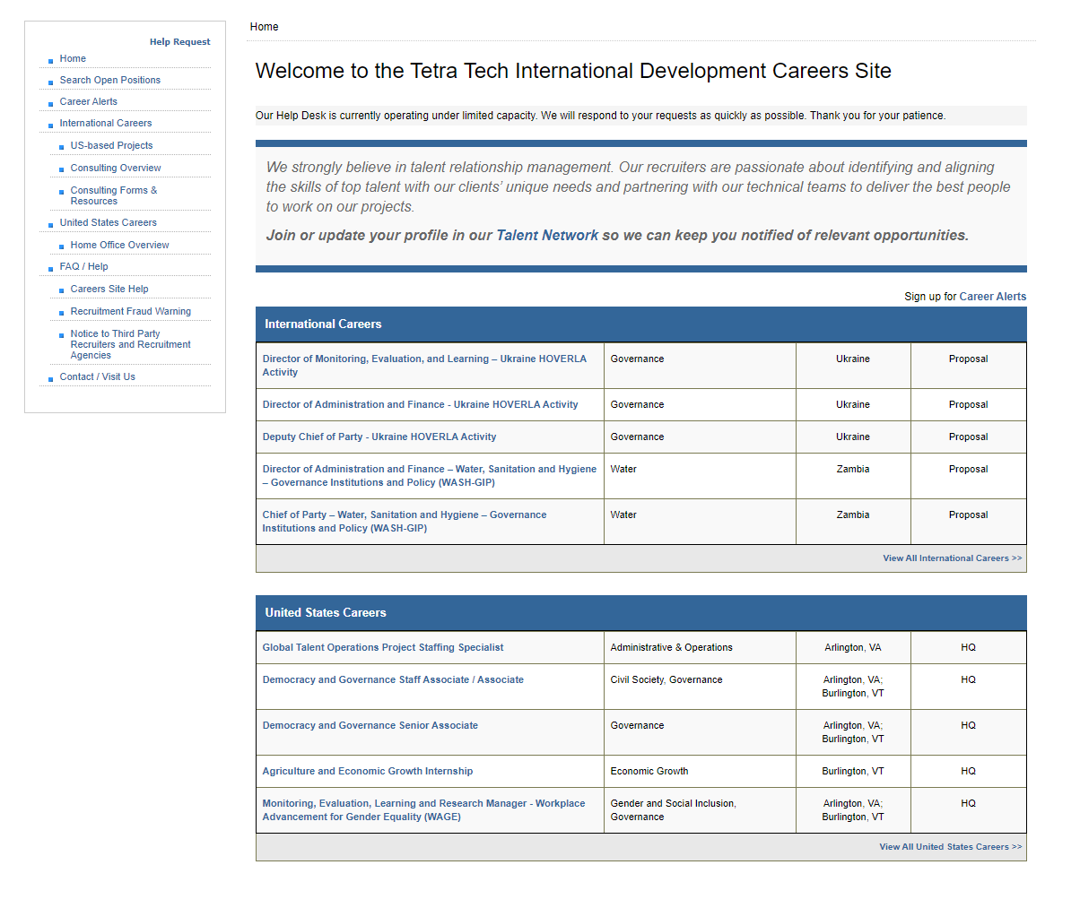

Search Open Positions:

You may search for job openings by using the Search Open Position in the left navigation menu.
You may search by Keyword, Practice Areas, Experience Levels, Job Classification, Location, Hire Type and Duration.

Careers Alerts:

If you would like to receive weekly Tetra Tech International Development Career Alerts notifying of recent postings by email you can subscribe here. You can unsubscribe at any time.

My CAREERS

The following sections are available once you establish an account.

Check Application Status:

Each application you submit will be listed in the Check Application Status section. You will be able to see the status of your application or retract your application.

Applications have three status’ - “Actively Recruiting”, “Position Closed” or “Not Selected”.

To update an application that is “Actively Recruiting” click on the posting title. The system will navigate you to your application. You may add or remove a document from your application and submit your application again.

If you retract an application, you will not be able to update it or apply again to the posting.

Edit Profile:

Your contact information and option to opt-in or out of data sharing. We recommend that you keep your profile up to date so that we may contact you regarding opportunities that arise.

Edit Professional Qualifications:

The Professional Qualifications page contains information regarding your Geographic Experience, Language Skills, Academic Background and Professional Skills. This aids our staff in locating you for potential opportunities.

Manage CV & Supporting Documents:

The document manager provides you the opportunity to Add/Delete your CV and other documentation to your on-line profile. The documents you add are available for submission with any job application. Any documentation you submit that is not tied into a job application will be uploaded into your file in our talent network roster.

Change Password:

Should you need to change your password that can be done here.

Close Your Account:

If you no longer wish to have an on-line account, you can close it. If you close your account, you will not be able to apply for positions. We can reactivate your account at any time.

Help Requests:

Should you need assistance with your account you may use the Help Request in the navigation bar on Careers site home page. Representatives are available Monday through Friday, from 8:00 a.m. to 4:00 p.m. eastern standard time. Representatives will respond to weekend requests on the next working business day.

Please be specific as possible regarding the issue you are having so our staff can assist you quickly.

If you have questions or need additional help please contact us at: IDS.CareerHelp@tetratech.com

Forget Password:

To reset your password, go to the Forgot Password screen and enter your email address:
https://careers.tetratechintdev.com/IDSCareers/App/Public/Forgotpwd.aspx

